Human Computer Interaction
(HCIN6222)
Part 2: Prototype
ST10438554

Due Date: 22 October 2025

Github link:https://github.com/ST10438554-kirby/HCIN6222_POE

Introduction

The second phase of the CampusPulse project transforms the Part 1 design justification into a functional prototype made in C# Windows Forms using Visual Studio Community 2022. The system aims to address a real problem observed in academic environments: fragmented event communication, by offering a unified interface where students may RSVP, vote in polls for future activities, keep track of forthcoming events, and log in with their institutional email.

Accessibility, design principles, interaction types, social and emotional engagement, usability, and desirable user experience are the Human Computer Interaction (HCI) concepts discussed in Part 1 and are represented by the prototype's four main screens: Login, Dashboard, Event Details, and My Calendar. Every screen contributes in a different way to these concepts, providing students with both emotional and practical satisfaction.

Prototype Overview
Instead of being an online system, the prototype was developed as a desktop application. Because of its robust event-driven architecture, drag-and-drop features, and integrated design environment, Visual Studio was chosen. To maximize learnability, the graphical user interface makes use of well-known Windows conventions.

Layer | Description
Presentation | LoginForm, MainForm, EventDetailsForm, My Calendar provide user interaction.
Logic | Handles authentication, event filtering, RSVP toggling, font-scaling, and poll voting.
Data | In-memory storage classes Event.cs and DataStore.cs simulate backend databases.

Usability Goals and Implementation Across Screens

According to Nielsen (1994), usability influences how well users can accomplish their objectives. Easy navigation, efficiency, error prevention, accessibility, learnability, and satisfaction were the six objectives outlined in Part 1, and each was achieved by means of particular screen elements.

Ease of Navigation

The navigation was purposefully shallow and linear: Login → Dashboard → Details/Calendar. Consistent button placement, menus, and category filters all lessen cognitive strain.

- Screen for Login: An easy start is ensured with a single input box and an action button; the font size and help link are positioned appropriately beneath.

- Dashboard Screen: Provides a sortable list view (lvEvents) and a drop-down filter (cbCategory) for easy browsing.

- The event details screen has been condensed into a single column so that users may concentrate only on the RSVP action.

- Calendar Screen: To draw attention to the primary activity, a clear "Vote" button is placed in the center.

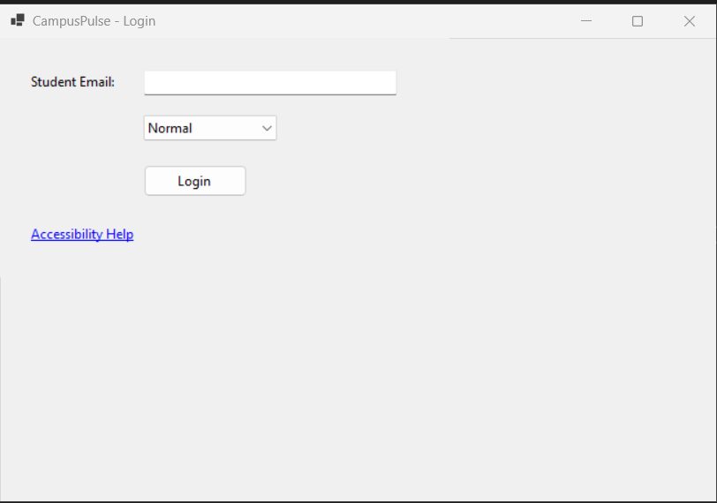
Screen 1

Efficiency

Efficiency is the least amount of work needed to do a task (Shneiderman et al., 2017).Events load on the Dashboard automatically; there is no need for a manual refresh at starting.
Toggling the RSVP in the Event Details One click quickly refreshes the attendee list and changes the screen's status.The My Calendar function removes the need for manual tracking by summarizing individual RSVPs with a single command.Before allowing access, Login automatically checks the email format, saving users from later unsuccessful attempts.

Error Prevention and Recovery
The prototype gently corrects users when they make mistakes, in accordance with Nielsen's (1994) heuristic of user control.
- Login Screen: Invalid email formats are identified using a regular-expression validator, which also offers remedial feedback.

- Event Details Screen: By clicking the same button again, you can cancel an RSVP.

- Dashboard: A non-intrusive prompt appears when you try to open information without choosing an event.

Error messages that are easy for people to understand, like "Please enter a valid email address," aid in users' speedy recovery.

Accessibility and User Satisfaction

Accessibility was integrated from the start after WCAG 2.1 (W3C, 2018). All other forms inherit the font scale options ("Small," "Normal," and "Large") from the Login Screen. Tooltips, high contrast lettering, and a logical tab structure ensure that the application may be used with a keyboard or mouse.

Forms that are visually appealing and include welcoming words, like "You have RSVPed to this event!" improve emotional satisfaction. Norman (2013). Reliability is reinforced by smooth operation and quick response, which meet the final usability criteria.

Aspects of User Experience
According to Hassenzahl (2010), UX combines pragmatic and hedonic qualities. The prototype not only functions efficiently but also evokes positive emotions.

Visual Appeal and Personalisation
Professionalism and readability are maintained through color contrast (dark text on a light background). Column alignment and icons create a simple, contemporary look that is free of distractions.The dashboard exhibits visual hierarchy: secondary elements are smaller and titles are bold. For emphasis, the login screen employs very little color.Details of the Event The event title is bolded on the screen to emphasize its significance.

On the Dashboard, the system welcomes users by name (email) ("Welcome, student@univ.edu"), fostering a sense of ownership. By displaying only the user's events, My Calendar further customizes the experience.

Cognitive Load Reduction and Social Connection

Extended descriptions are located in the Event Details dialog; only pertinent details are initially accessible. Grouping and white space enhance scannability and guarantee attention to important tasks. Each Event Details screen's attendance list shows other attendees, encouraging social interaction. By enabling community decision-making, the Poll feature promotes inclusivity.

Design Principles and Screen Applications

Principle | Implementation & Screen Example
Consistency | Identical colour palette, font, and control positions. Login and Dashboard share button alignment.
Visibility of System Status | Pop-up confirmations and live RSVP counts show immediate system state.
User Control and Freedom | RSVP toggles and navigational freedom between Dashboard and Details allow reversal of actions.
Simplicity and Minimalism | Each screen displays only essential functions; clutter avoided.
Accessibility | Font controls and keyboard navigation ensure inclusivity.
Aesthetic Design | Balanced layouts, adequate spacing, and moderate colour use (Tractinsky, 2004).
Flexibility and Efficiency | Both novice and experienced users can perform the same tasks quickly using mouse or keyboard.

Login Screen: Simplicity and feedback.
Dashboard: Consistency and visibility.
Event Details: User control and flexibility.
Calendar Screen: Feedback and inclusivity.

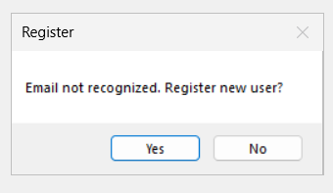
Screen 2

Interaction Types

According to Preece, Rogers, and Sharp (2019), CampusPulse should display four different kinds of interactions: The multi-modal strategy of the prototype guarantees that both exploratory users (who browse categories) and inexperienced users (who prefer clear buttons) feel accommodated.

Interaction Type | Description | Example Screen
Instructing | Direct commands executed by clicking buttons. | Login, RSVP, Vote.
Conversing | System dialogues acknowledge user input. | Message boxes during login or RSVP.
Manipulating | Selection of list items simulates direct control. | Dashboard ListView highlighting and sorting.
Exploring | Users navigate through filters and categories to discover events. | Dashboard search and category filter.

Social and Emotional Interactions
One of the main design goals was to foster community. Repeated involvement is encouraged by emotional design (Hassenzahl, 2010).

- Attendee List: Promotes involvement through social proof; peer registration fosters a feeling of community.

- Calendar Participation: Fosters pride and agency by giving users the ability to influence future occurrences.

- Positive Language: In confirmation dialogues, encouraging prompts like "Great choice!" are used.

- Support and Assistance: The Login Help link demonstrates consideration for users who need assistance with accessibility.
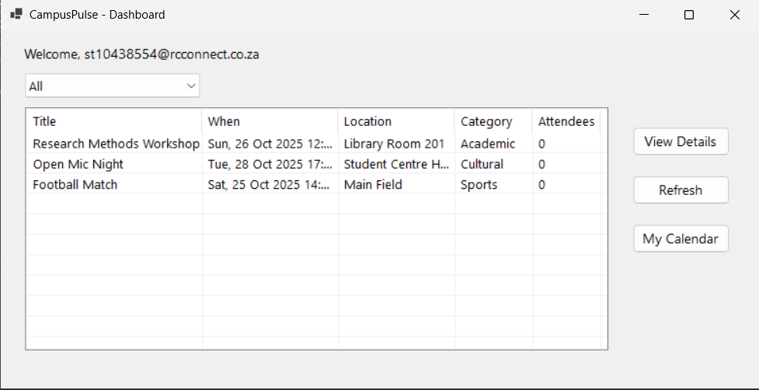
Screen 3

Accessibility and WCAG 2.1 Compliance
According to W3C (2018), accessibility guarantees that all pupils, including those with disabilities, may utilize the platform.

Perceptible

Font sizes that can be changed make it easier for people with visual impairments to read.A black-on-white color scheme with a lot of contrast helps you avoid depending just on color.

Operable
Without a mouse, functioning is guaranteed with full keyboard navigation (Tab, Enter).Users with low dexterity benefit from large buttons that are spaced sufficiently apart.

Comprehending and Dependable

Confusion is decreased by using straightforward labels ("Login," "RSVP," and "My Calendar") and providing direct feedback.Designed to enable screen readers and accessibility APIs using normal Windows Forms controls.

Each screen makes a contribution:

- Login: Font size and link to help.
- Dashboard: Tabs are arranged logically for event navigation.
- Event Information: Basic language and tooltips.
- Large interactive components and little text make up the poll.

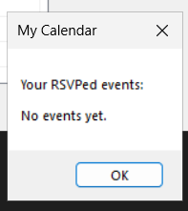
Screen 4

Screen-by-Screen Summary

Screen | Key Purpose | HCI Concepts Demonstrated
LoginForm | Entry point; verifies user email; allows font scaling. | Learnability, error prevention, accessibility.
MainForm (Dashboard) | Displays event list, filters, and navigation buttons. | Efficiency, consistency, exploring interaction.
EventDetailsForm | Shows event info, RSVP toggle, attendee list. | Feedback, social connection, user control.
PollForm and My Calendar | Enables community input and personal summary. | Conversing interaction, emotional engagement, personalisation.

Conclusion

The creation of CampusPulse transformed intangible HCI concepts into concrete design choices. It was very illuminating to implement accessibility controls because even a basic function like font scaling significantly improved inclusivity. The iterative process demonstrated how usability and user experience are interdependent; aesthetically pleasing interfaces also enhance functional performance by boosting user confidence.

The shift from theory to prototype improved comprehension of Nielsen's (1994) heuristics, especially user control and system status visibility. Additionally, it reaffirmed the importance of emotional design (Norman, 2013), since users' judgments of friendliness and dependability were influenced by even basic feedback dialogs.

This report recorded the process of converting the CampusPulse concept from conceptual design to an HCI-theorized interactive C# prototype. Specific usability, user experience, and accessibility goals are embodied in each screen:

- Every screen incorporates particular accessibility, UX, and usability goals.
- The login screen is user-friendly, accessible, and error-proof.

- Dashboard: Exploration, efficiency, and design coherence.

- Event specifics: visibility, feedback, and social interaction.

- My Calendar: Customization and community engagement.

All of these elements show how well-considered design turns technology into a tool that has social value and improves campus life. Along with validating the findings of Part 1, the prototype creates a workable blueprint for next campus information systems.

References
Hassenzahl, M. (2010) Experience Design: Technology for All the Right Reasons. Morgan & Claypool.
Microsoft Docs (2024) Windows Forms overview. Available at: https://learn.microsoft.com/windows/apps/design (Accessed: [insert date]).
Nielsen, J. (1994) Usability Engineering. Academic Press.
Norman, D. A. (2013) The Design of Everyday Things: Revised and Expanded Edition. New York: Basic Books.
Preece, J., Rogers, Y. and Sharp, H. (2019) Interaction Design: Beyond Human–Computer Interaction. 5th edn. Chichester: Wiley.
Shneiderman, B., Plaisant, C., Cohen, M., Jacobs, S., Elmqvist, N. and Diakopoulos, N. (2017) Designing the User Interface: Strategies for Effective Human–Computer Interaction. 6th edn. Pearson.
Tractinsky, N. (2004) ‘Towards the study of aesthetics in information technology’, Proceedings of the 25th International Conference on Information Systems (ICIS), pp. 771–780.
World Wide Web Consortium (W3C) (2018) Web Content Accessibility Guidelines (WCAG) 2.1. Available at: https://www.w3.org/TR/WCAG21/ (Accessed: [insert date]).

